
AN ISO 9001:2008 COMPANY DT: 01/07/16

Fully Auto 7G-370 Incense making machine.
Beware from duplication and cheater.
Nobody our Ex-partner
- Indian Manufacturer & Exporter.
- Hardened Gears & grounded shaft.
- Heavy & Rigid Structure.
- Standard motor 1.5 H.P. (optional 2.0 H.P.)
- Problem less DC motor, DC Gear motor & Sensor (Compare to other)
- Quality control at every stage in machine manufacturing.
- Air-Cooled bowl housing.
- Oil-cooling system for piston.
- Long life die, Rocket, cleaning rod, rocket rod, and machine manual.
- Spares available at any time.
- Full Technical support after sales.
- Lifetime telephonic technical support free after sales.
- Soundless and smooth working.
- World’s high production up to 135 kg dry/8Hr.only.
- Counting meter.
- Machine weight: 160 kg.
- 9 months warranty in main motor, inverter Drive, Gearbox, DC card & Slider.

Price for 1 machine 1 -Phase INR 1, 40,000/- (ex-factory)
Extra: CST/VAT, freight, packing, forwarding and Installation.
Delivery within 10 to 15 days of confirmation with 50% of advance
And balance at a time of delivery at my factory.
You may our video on youtube.com
https://www.youtube.com/watch?v=2-WhOrQHs_8

Fully Auto 7G-370 Incense making machine

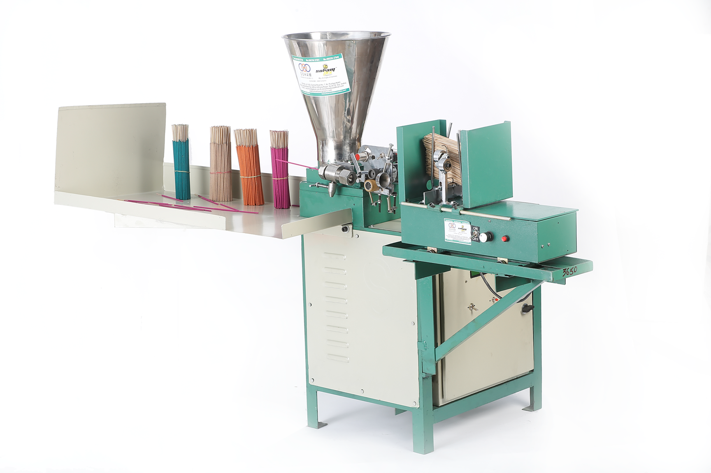

For Sohamtex Engineers

Sonu Kanojiya ( Sales Manager) 098254 57848

TIN GST. 24221802545 Dates. 18-12-2003
- TIN CST. 24721802545 Dates. 18-12-2003

