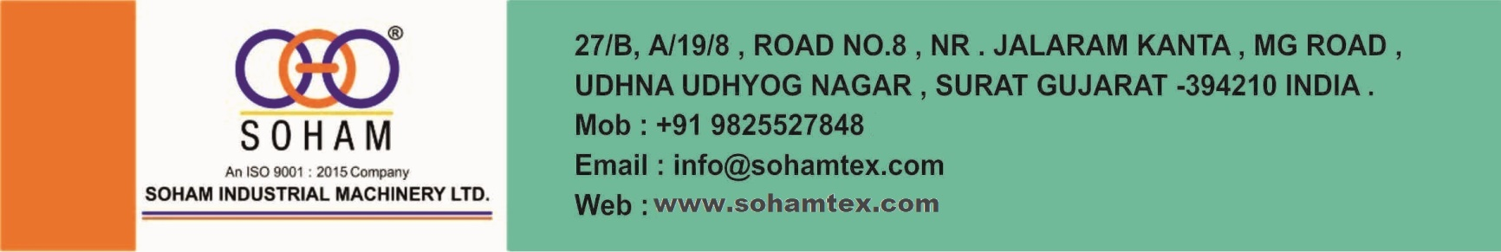
AN ISO 9001:2015 COMPANY
Date: 01/03/2026
WHY SOHAM.
- ESTABLISHMENT YEAR: 2001
- WORK TYPE: MACHINE MANUFACTURING FROM LAST 25 YEARS.
- WORK TYPE: FROM 2011 MACHINE MANU. FOR INCENSE, DHOOP INDS &
- WE PROVIDE AUTOMATIONS FOR ANY FIELD.
- FACTORY SPACE: 20,000 SQ. FEET.
- STAFF IN FACTORY: 50 PLUS
- ALL PARTS OF MACHINE’S ARE MADE INSIDE THE FACTORY.
- ENGINEERS IN FACTORY: 15 PLUS WITH OWNER.
- SOLD OUT MACHINES: 30000 PLUS (INDIA & EXPORT)
- SEPARATE SPARE DEPARTMENT WITH ALL PART’S STOCK AVAILABILTY
- QC OF ALL PARTS: BY ENGINEERS
- AUTOMATIC CNC, LAERCUT & VMC MACHINES FOR IN-HOUSE PARTS MAKING.
- SEPARATE SERVICE DEPT.: WITH 4 PERSONS FOR ALL TYPES OF MACHINES.
- ALL RAW MATERIALS AVAILBLE FOR INCENSE & DHOOP INDS.
- PERFUMES, DEP, BOXES, & POUCH ALSO AVAILABLE.
- LIFE TIME, TELEPHONIC SERVICE FREE FOR 9AM TO 6PM.
- SUPPLIED MACHINES TO GODREJ, VENDOR OF ITC & CYCLE
- COMPANY AND MANY MORE.
- WE CAN MAKE ANY TYPE OF MACHINES AS PER CUSTOMR’S REQUIREMENT.
- MACHINE LIFE: MIN. 10 YEARS.
- POWER BILL LESS
- PRODUCTION COST LESS.
- MAINTENCE LESS

ABROAD CLIENT LIST
- SANGGANATHI SDN.BHD.- MALAYSIA
- C/O EMELLAN (M)SND BHD- MALAYSIA
- AROMATIC LTD- RUSSIA
- WAGAGEN BANK S.C- ETHIOPIA
- SAMIR MEIZU-TUNISIA
- HINGURANA GROUP- SRI LANKA
- SUWANDA INDUSTRIES PVT LTD-SRI LANKA
- GODREJ NIGERIA LTD- NIGERIA -WEST AFRICA
- METSEC CABLES LTD- KENYA
- INDUT INDUSTRIAL PLC - ETHIOPIA
- MC MITRA SDN BHD -MALAYSIA
- SHREE CHAMUNDU ENTERPRISES - AFRICA
- EB CREASY & COMAPANY PLC - SRI LANKA
- ZIBO UNIQUE MACHINERY TECHNOLOGY CO LTD- CHINA
- ASIA PLANTATION CAPITAL -MALAYSIA
- MUTEB FIAISAL ABMED MUTED MASEEF SHOWROOM - SAUDI ARABIA
- MIG MEDIA NEURONS LTD- SRI LANKA
- ATHULA PARANAYAPA SERVICES PVT LTD - SRI LANKA
- KANROSE INTERNATIONAL PVT LTD - SRILANKA
- SIDDHALEPA AYURVEDA HARBALS PVT LTD - SRI LANKA
- CARGO MARKETING INTERNATIONAL - BRAZIL
- VOSTTORG CO LTD – RUSSIA
- QUALITY INCENSE INCE -- INCENSE COUNTING 11 INCH USA
- SUNVEAT FOODS LIMITED - Thika Kenya

Our Valuable client list:
- Godrej Consumer Products Ltd- Himachal Pradesh (8 Machine)
- Mysore Deep Perfumery House --Indore, Madhya Pradesh, India.
- Pragathi international - Bangalore
- Simran Export Incense Pvt Ltd- Delhi
- Deva Agarbatti Products- Kurnool
- Geofast Industry Indial Ltd- Hyderabad
- Shree Cha enterprise- Simoga
- Hem Corporation Pvt Ltd- Thane (2 machine)
- Pitambari Products pvt Ltd- Maharashtra
- Mirakal- Pune
- Shah Fragrance- Ahmedabad
- C.R.Agarbatti- Bangalore
- Utsav Fragrance- Rajkot (2 Machine)
- Krutika Industries - Jamjodhpur
- Raghubira Carbons- Jamnagar (3 Machine)
- Pricious International- Ankleshvar (2 Machine)
- Kamkhya Aromatics (ITC)- Kanpur (2 Machine)
- Shree Krishna Gopal Udyog- Punjab
- Su Moon - Kerala
- Rajshree Fince Pvt Ltd- Indore
- Ahuja Agarbatti- Raipur (2 Machine)
- Sun Tempal - Godia
- The Bright Impex- Karnataka
- Kuber Group of India- Delhi
- Bharat food And Beverages Pvt Ltd- Noida
- Shree Ram Products- Ratlam
- Arun Gupta- Delhi
- Trivani Sales- Kannouj
- Amalya Herbals- Bhopal
- Balaji Agrabatti Works- Balotra
- Shree Shyam Industries- Rourkela
- Harsh Incense- Sagara
- Nishan Products- Ahmedabad
- Settelite Corporation- Gondia
- Shyam Traders- AP
- Shree balaji Enterprises- Raipur (3 Machine)
- M W & Sons- Sholapur, MH
- Satellite Corporation - Gondiya
- Balaji agarbatti works- Balotra
- Vikash Potteries- Jharkhand (2 machine)
- Kam products – Kerala
- Sunshine Agency-Chennai (2 Machine)
- ABL ENTERPRISE- BURDHAMAN, WB
- Sai Samartha Cosmetics Pvt ltd- Palghar, MH
- IXORA EXPORTS PVT LTD- Kamrej, Surat
- FOUR ACES FRAGRANCES LLP-Indore, Madhya Pradesh, India.
- SHREE SAKARI INDUSTRIES – Patna (2 machine)
- JESIKA ENTERPRISE – Assam
- PRAGATISHEEL ENGINEERING- Dewas, MP
- SHRI SAI SALES- Durg, chhatishgrah
- KANPUR FLOWERCYCLING PVT LTD- Kanpur
- SUBHAKART INDIA PVT LTD- Mumbai
- MAA VISHNUPRIYA FACTORY- Boisar, MH
- MOHIT SHEKHDA -Surat, Gujarat, India.
- MPR POJA PRODUCTS -- CHENNAI
- ADITYA PERFUMERY --AKOLA MH
- Marvellite Aromatics Pvt Ltd -Anjar, Gujarat, India. Dipping machine
- Forest Bird Productions Shaurya Samanta ---Murshidabad, West Bengal, India
- Globe perfumery Pvt Ltd -Begusarai, Bihar, India.
- Pavithram industries :--- Vellore, Tamil Nadu, India.---
- Bhaiv laxmi production, :-- Barasat, West Bengal, India.
- Shree shyam industries - Rourkela, Orissa, India.
- NATURIS COSMETICS PVT. LTD- Jammu, Jammu and Kashmir, India. Box packing
- Parekh Sons - Gondia, Maharashtra, India. Dipping machine
- Globe perfumery Pvt Ltd - Begusarai, Bihar, India.
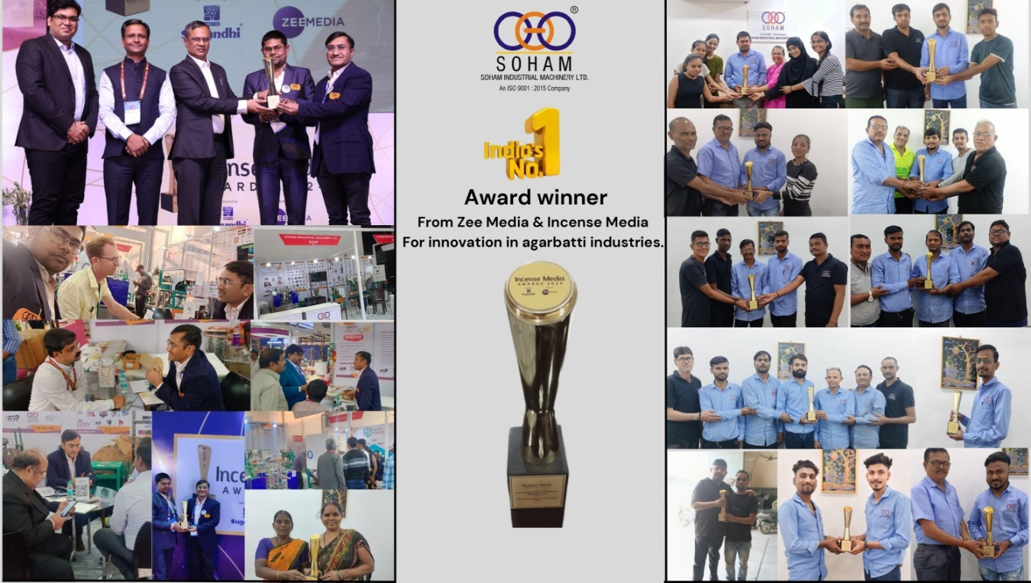
AN ISO 9001:2015 COMPONY
AUTOMATIC PVC PIPE BENDING MACHINE (2 CAVITY)
Machine design and working theory copyright by sohamtex engineers
- First time in India
- Machine speed:400-450pieces /HR. (Depend on Size& Quality)

- Pneumatic based PVC pipe bending machine.
- Machine type: Fully automatic
- Required power for machine:1HPSignal Phase
- Compressor:7.5 HP Three Phase (Client’s Scope)
- Total power for machine: 8.5 HP 3 Phase
- Length of Pipe: as per your sample & approval
- Pipe Quality: ISI & Non-ISI
- Diameter:19, 20 & 25 mm (die charge extra)
- Req. Pipe weight: (19mm – 353 gm), (20mm – 370 gm), (25mm – 503 gm) and above only.
SCAN ME
- Bending: 90 Degree (as per your requirement)
- Socketing: both sides
- Machine length:6*5*5 Feet
- PLC based automatic controller with HMI.
- Machine weight:250Kg
- Cost per bend:0.25Rs. / Bend
- Free: Training of machine operation and general maintenance at Surat.
- Warranty: 9 months in PLC, HMI and Temperature Controller.
- Telephonic service free for 2 years (Monday to Saturday 9 AM to 6 PM, Sunday Weekly off) service will be discontinue if you use other company’s spare in this machine.
- Payable service available any time.
- This machine designed by our Engineer.
- Easy to operate & low maintenance.
Made in India
You may show on video you tube: ----https://youtu.be/zeClJpQPsC0

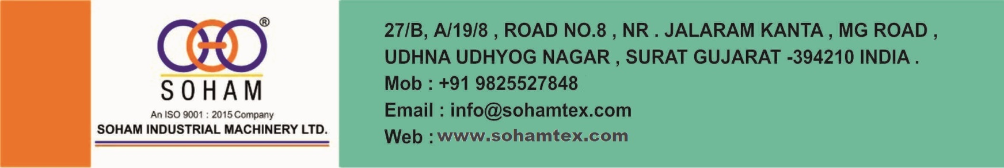

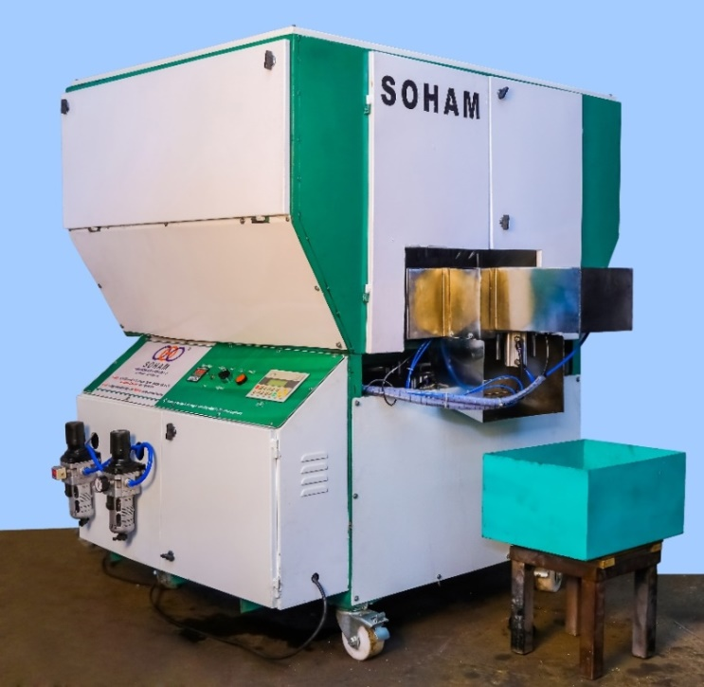
Terms and Conditions:
Price per machine INR 4, 51,000/- (ex-factory)
Die cost extra
For 19 & 20 mm- 38,000
for 25 mm- 45,000
Extra: Tax, packing, forwarding, transportation & installation.
Training and installation are compulsory for this machine.
Delivery within 30 days of confirmation with 50% of advance and balance at a time of delivery from our factory.
Note : Accidentally break down, overheating and over voltage fluctuation problem not consider in warranty.
Thank you
For Soham Industrial Machinery Ltd
Sonu Kanojiya 98254 57848
(Sales Manager)

OUR VALUBALE CLIENT
1. SRI DATTA POLYMER INDUSTRIES (POLYLINE)- VIJYAWADA.
2. SUDHAKAR IRRIGATAION SYSTEMS (P) LTD-NELLORE, AP
3. SHIV POLYMERS- RAJKOT
4. RUNGTA DISTRIBUTER- GORKHPUR
5. JAY KHODIYAR ENTERPRISE- AHMEDABAD (3 Machine)
6. ASCENT POLYMER- RAIPUR
7. ASPECT SOLUTION- THANE.
8. KUNSONS PIPES PVT LTD.- COIMBTORE
9. ARYAN INDUSTRIES- SURAT
10. TULSYAN AGENCIES- JHARKHAND
11. GAYTRI INDUSTRIES- JHARKHAND
13. PRESS FIT – THANE (3 Machine)
14. MAHARISHI SVADESHI KENDRA- BENGALORE
15. PARIHAR PLAST- CHENNAI
16. SHINGLA INDUSTRIAES - PUNJAB
17. NATIONAL ELECTRIC & SWITCH GEAR- BIHAR
18. JAIN PLAST- COIMBTORE
19. VIHAN INDUSTRIES- BENGALORE
20. PRESTIGE INTERNATIONAL-CHENNAI
21. VALAPPA EXIM PVT LTD- KERALA
22. M.M.TRADERS- VILLUPURAM
23. Vasan's Industries- Nagpur
24. Metsec Cables Ltd.- Kenya
25. Sampat Industries- Sangli, MH
26. Veer Pipes & fittings- Rajkot

